Global Sales Data Analysis Report

4/2/2026

Excel for Data Analysis

<Soham Dilip Desai>

 | INTRODUCTION  The project focuses on a comprehensive data analysis of a global sales dataset containing 2000 individual records of various electronic and household products sold across different countries. The objective of this study is to explore key sales metrics, customer behavior, product performance, and regional trends to uncover meaningful insights that can drive business decisions.  Using a combination of Excel-based tools such as pivot tables, filters, conditional formatting, and charts, this analysis delves into patterns related to product-wise revenue, discount impact, profit margins, shipping delays, and geographical sales distribution. The dataset includes essential fields such as product category, units sold, unit cost and price, sales region, customer details, and transaction dates.  This investigation aims to identify high-performing products, top revenue-generating regions, and delivery efficiency, while also highlighting potential issues like high discount dependencies or delayed shipments. The findings will support stakeholders in understanding market dynamics and improving future sales strategies, inventory planning, and customer targeting.  INFORMATION ABOUT DATA SET  The dataset comprises 2000 records of global sales transactions for various consumer and household products. It captures key business metrics across multiple countries and regions, making it ideal for performing business analysis and deriving actionable insights. The dataset is well-structured and enables exploration of sales trends, profitability, and regional performance. It includes the following major components:  - Order Details  (Order ID, Order Date, Ship Date, Order Priority)  - Customer Information  (Customer Name, Segment, Region)  - Product Details  (Item Type, Sales Channel, Unit Price, Unit Cost, Units Sold)  - Financials  (Total Revenue, Total Cost, Total Profit, Discounts if any)  - Geographic Details  (Country, Region)  - Person Responsible  (Sales Representative or Employee Name where applicable)  DATA PREPRATION  Before analysis, the dataset underwent several preparation steps to ensure accuracy, consistency, and usability. Given the size and of the data (~2,000 records), proper cleaning and transformation were essential for effective analysis.  DATA CLEANING  - Removed extra spaces, special characters, and formatting inconsistencies (e.g., in dates, currencies, and names).  - Converted date fields (Order Date and Ship Date) into standardized date formats.  - Transformed numerical fields like Sales, Profit, Discount, and Shipping Cost from text (with symbols like $ or %) into numeric types for accurate calculation.  QUICK INSIGHTS (Using Conditional Formatting, Filter, custom filters, sorts.)  - Highest Total Sales came from the product category Baby Food, contributing a significant portion of overall revenue.  - Cosmetics generated the highest profit percentage (19%) among all product categories.  - Fruits category showed 0% contribution to total revenue, indicating a possible need for reevaluation or removal.  - Using conditional formatting, it was observed that some products consistently have high sales but low profits, indicating possible over-discounting or high cost.  - Custom filters revealed that specific regions underperform despite large order volumes—highlighting logistic or pricing issues.  - Snacks and Clothes have low profit contribution (5%)—marketing focus or price structure might need adjustment.  - Sorting by Order Priority shows that high-priority orders don’t always correlate with higher revenue, indicating inefficiencies in order allocation or handling.  DETAILED INSIGHTS  - Summary Statistics:  - Regional Performance:  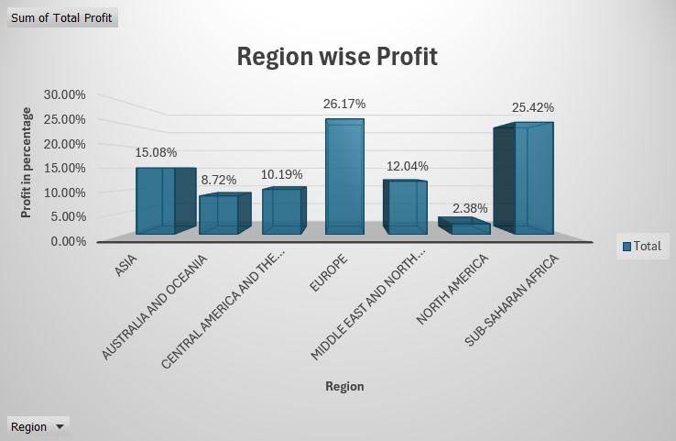  - Online/Offline Sales:  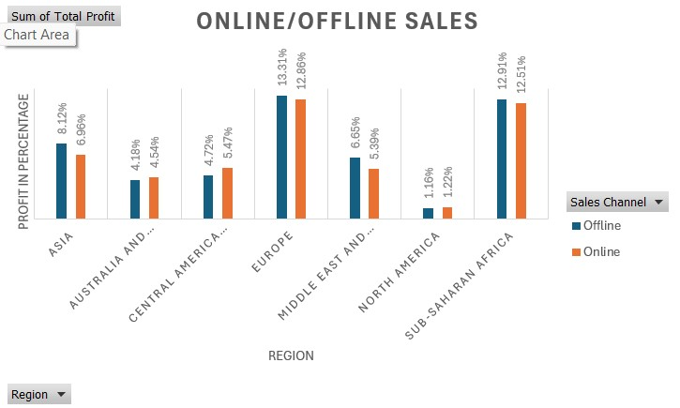  - Total Revenue by Products:  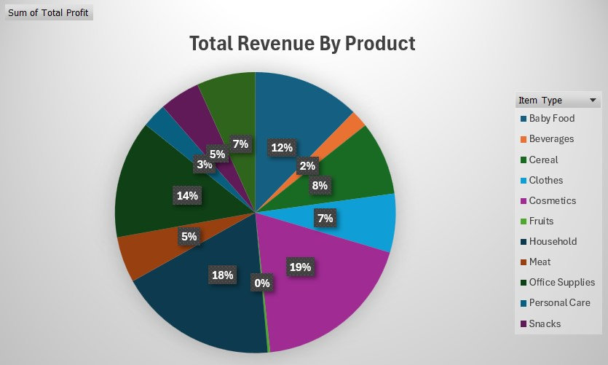  - Top 3 Products  - These products are bestselling.  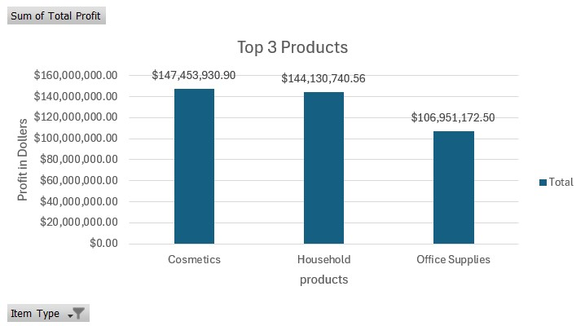  - Top 3 Region By Sales  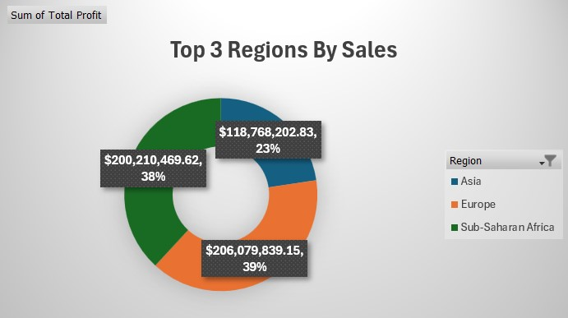  ACTION STEPS  - Enhance Marketing in Underperforming Regions:  - Some regions show consistently lower sales. Increase brand presence and customer engagement in those areas through localized campaigns, offers, or partnerships.  - Promote High-Profit Products:  - Identify and prioritize the promotion of products with high profit margins (e.g., Cosmetics and Office supplies). Increase their visibility through online ads, featured listings, and recommendations.  - Promote High-Profit Categories More Aggressively:  - Snacks (19%), Baby Food (18%), and Household (14%) are the top contributors to profit. Focus marketing efforts and shelf space on these items to further boost revenue.  - Optimize Strategies for Low-Contributing Categories:  - Cereal (2%), Cosmetics (3%), and Fruits (0%) have low or negligible profit contribution. Reevaluate pricing, promotions, or even consider phasing out underperforming SKUs.  - Investigate Causes for Zero Profit in Fruits (0%):  - Fruits generating no profit is a red flag. Examine supply costs, spoilage rates, or discounting practices to identify losses and corrective steps.  - Strengthen Medium-Growth Categories:  - Personal Care (12%), Clothes (8%), and Office Supplies (7%) are solid contributors. Focus on increasing their market share through bundled offers or strategic pricing.  - Evaluate Customer Preferences:  - The data suggests strong customer preference for Snacks and Baby Food. Use this insight to plan inventory and seasonal promotions accordingly.  CONCLSION:  - Cosmetics, Household products and Office Supplies are top-performing categories in terms of both sales and profit, particularly in the region.  - The Corporate customer segment showed strong loyalty, especially for frequently used office essentials like Phones and Binders.  - This project provided a comprehensive analysis of 2000 global sales transactions across a wide range of consumer and household products. Through detailed examination using Excel tools such as filtering, sorting, conditional formatting, and pivot tables, key patterns and trends in product performance, regional demand, and profitability were identified. |  | -
  Row Labels | Sum of Total Cost | Sum of Total Profit
  Baby Food | 8.61% | 12.33%
  Beverages | 1.70% | 1.99%
  Cereal | 4.72% | 8.50%
  Clothes | 1.38% | 6.76%
  Cosmetics | 11.90% | 18.72%
  Fruits | 0.35% | 0.29%
  Household | 23.29% | 18.30%
  Meat | 14.12% | 5.28%
  Office Supplies | 23.70% | 13.58%
  Personal Care | 2.68% | 2.82%
  Snacks | 3.46% | 4.67%
  Vegetables | 4.09% | 6.76%
  Grand Total | 100.00% | 100.00%

